YUCDC Fall Program Newsletter 2018
Administrative Staffing Team:
Mabel Davis and Sera Fernandes
You may call us at: 416-736-5190 or email at daycare@yorku.ca
Good Bye Summer and Hello Fall!

YUCDC
Celebrated the End of Summer Fun with Mr. Spaghetti Legs!

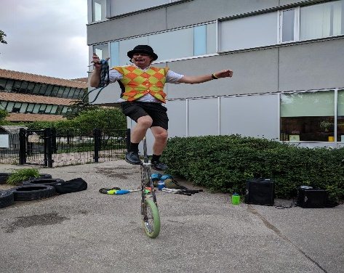

Mr. Spaghetti Legs shared his magic and tricks with the children and staff at our end of the Summer Pizza Nova Party. Lots of face painting, fun and games were organized by two of our summer staff, Hilary Doan and Pervena Sivarajah.

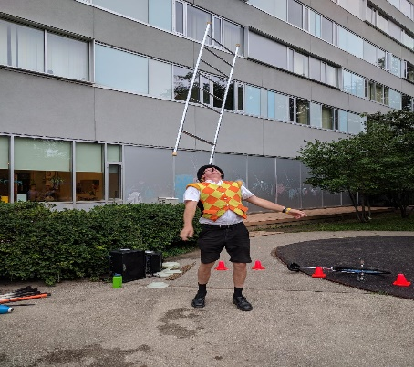

Tatiana Kekham Returns to
Share Her Musical Talents this Fall!

Tatiana, a certified music teacher who is
currently studying Early Childhood Education at
Seneca College, has returned from her trip to
Russia and will continue to share her musical
talents with our Infants, Toddlers and
Preschoolers every Friday morning this Fall.

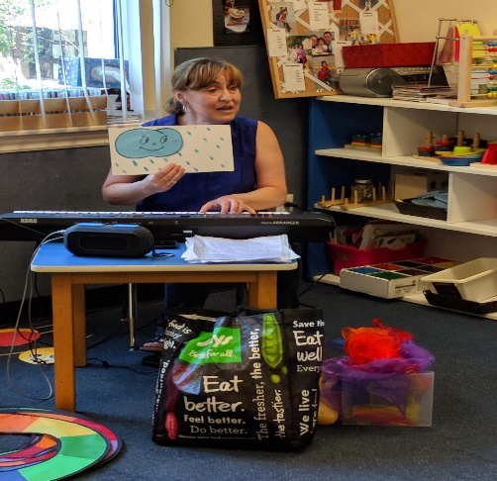

YUCDC Welcomes Back
Early Childhood Education Students

Students from Anderson and George Brown College’s Early Childhood Programs have returned for their fall session. Please join our Staffing Team in welcoming them into our Infant, Toddler and Preschool Programs.

Parents as Partners

Thank you for your continued donations of gently used toys and books for our classrooms and recycled tires and perennials for our playground.

Investing in Our Children’s Play Spaces

With a fresh coat of paint, new baseboards, up-to-date millwork and child-sized sinks and toilets, our Infants and Preschoolers are starting this new school year with amazing new play spaces.

Please join the YUCDC Board of Directors and Staff in thanking: the Administration and Human Resources at York University, Program Advisors from the Ministry of Education Helen Sipione and Salpi DiGiandomenico, District Consultant Darlene Thompson from Toronto Children’s Services and Umair Qureshi from Toronto Public Health and Humber Child Care Resource Consultants Jessica Lauzon and Josie Iannaccio and for helping us to make these new play spaces possible for our children.

We are excited to announce that Index Construction is close to completing the renovations in our School Age Room and has started to work on our Cubby Rooms!

More details will follow from York University as to when they will start giving a fresh look to our Toddler and Kinder Spaces.

Take a Peak at Our Infant Play Space

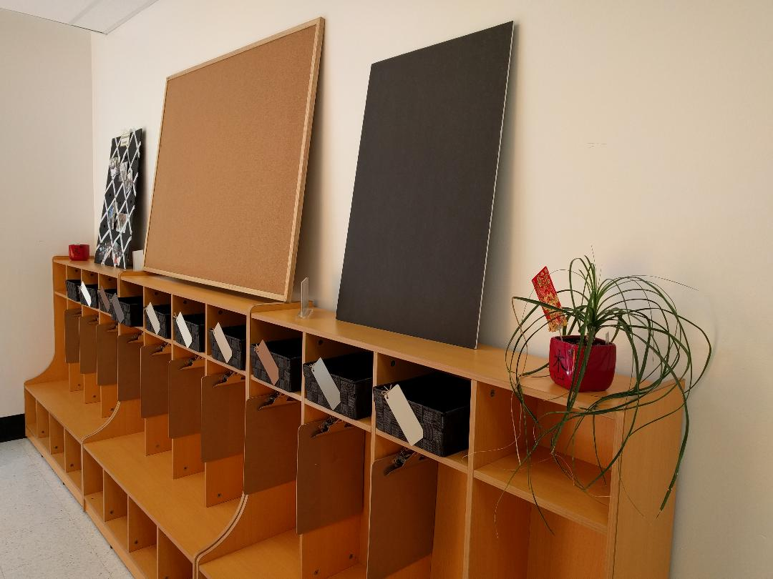
A special thank you to
Andrea Rochow
for helping us to assemble these cubbies!
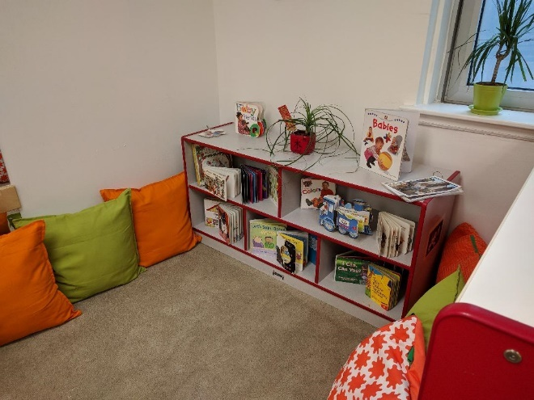
Cushions help to make
our Language and Literacy Area soft and cozy!
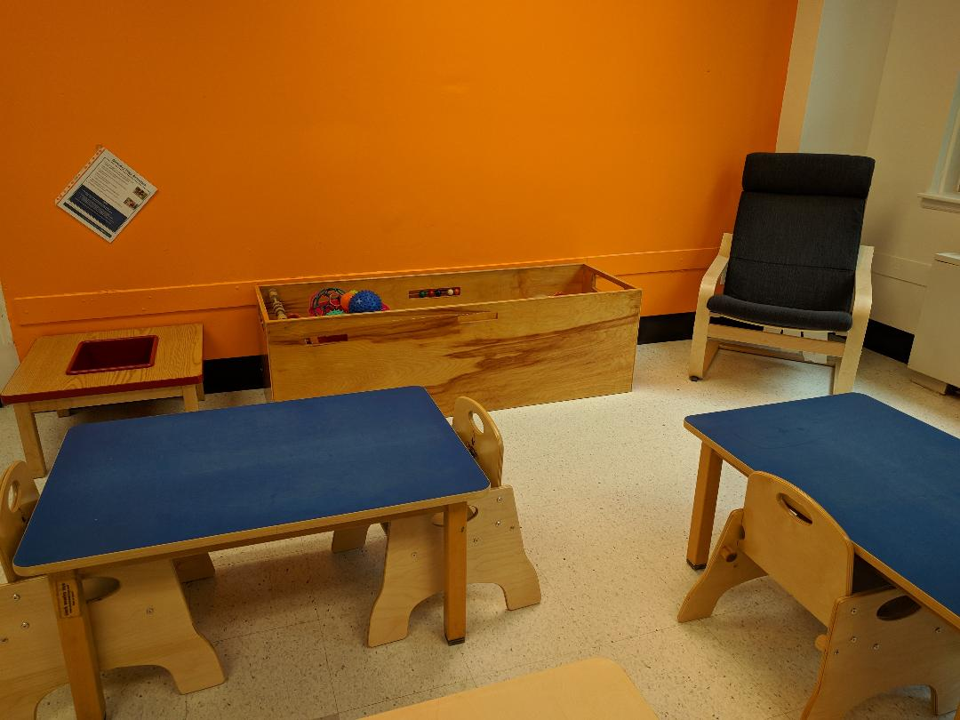
There are brand new wooden chairs
for our Infants to use during our
meal times and creative sessions!
How Does Learning Happen
In PRESCHOOL A’s New Play Space:
Through Four Foundations of Learning

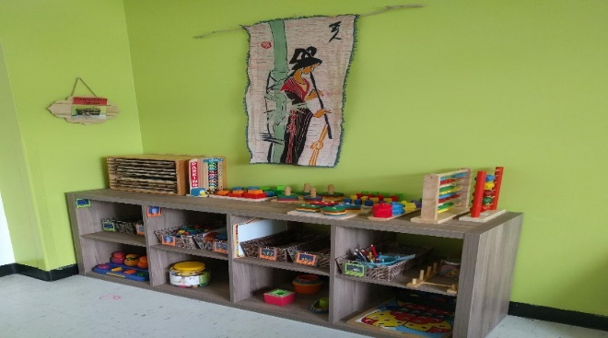
BELONGING: Cultivating
Authentic Relationships
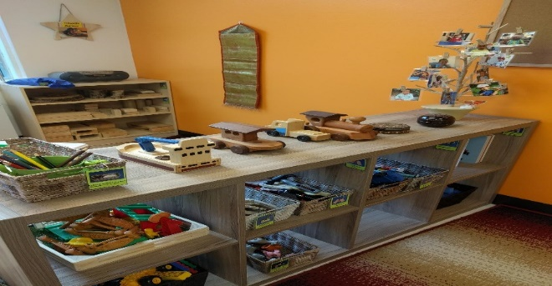
WELL-BEING: Nurturing
Healthy Development and Well-Being
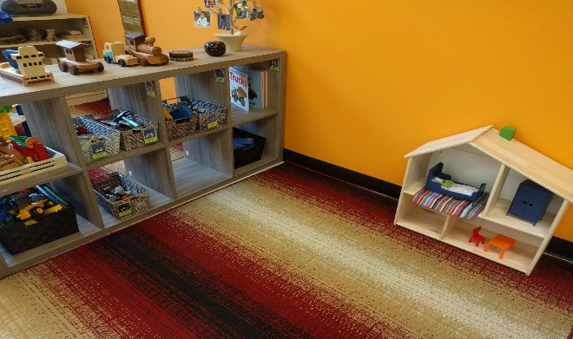
ENGAGEMENT: Creating through
Exploration, Play and Inquiry
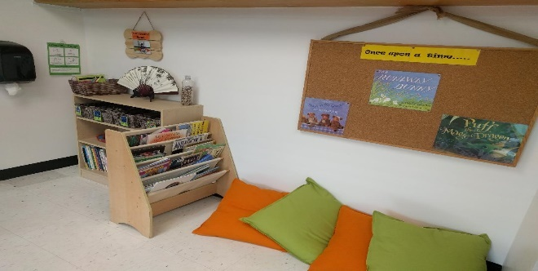
EXPRESSION: Fostering
Communication and Expression

Look How PRESCHOOL B is
Supporting Early Learning in
Our New Play Space!

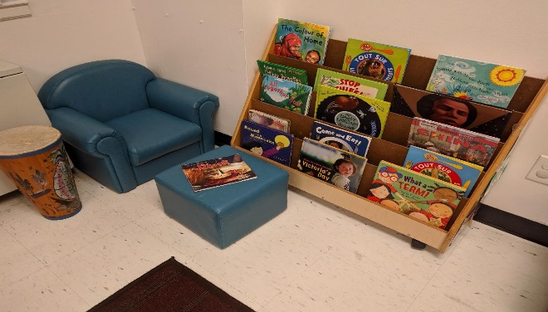
RESPECTING Diversity, Equity & Inclusion

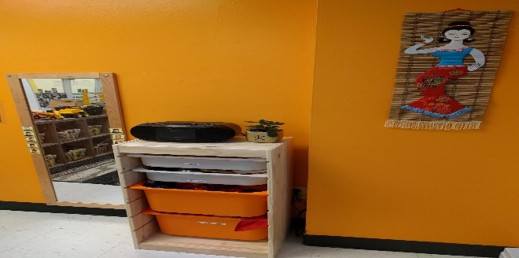
PARTNERING with Family & Community

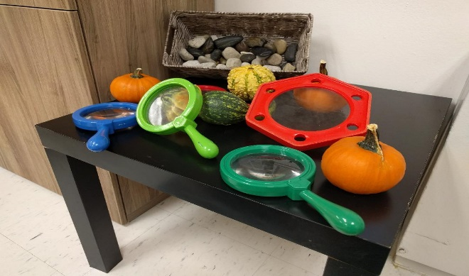
CAPITALIZING on
a Child’s Natural Curiosity Through Play
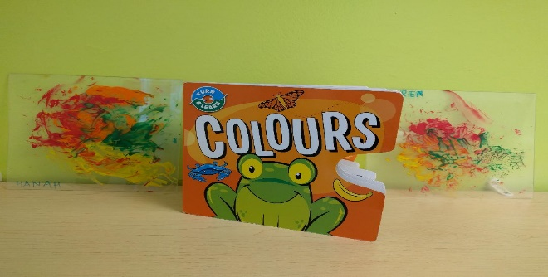
SUPPORTING
Early Learning with a Planned Curriculum

Interested in Sharing
Your Time and Talent?

The York University Co-operative Centre
is seeking parents and members from the
York University Community to become a member of the Board of Directors.

We are seeking individuals with diverse skills,
knowledge and time.

A new slate of Directors and Officers
will be selected at our next
Annual General Meeting.

For more information or if you would like to be considered, please e-mail your interest to daycare@yorku.ca by October 31st.

Mark Your Calendar for
YUCDC’S Annual General Meeting

Date: Wednesday, November 7th, 2018

Time: 5:30 pm until 7:00 pm
Snack foods will be available along with
items for a raffle draw

Place: Atkinson Residence Party Room 128

A Program Has Been Planned for Your Child!

5:30 Dinner provided
6:00 Entertainment by James Funny Hat
7:00 Home

More Details to Follow!

Messages From
The YUCDC Office & Board of Directors

CHILD CARE WORKER AND EARLY CHILDHOOD EDUCATOR’S APPRECIATION DAY: On Tuesday, October 16th, please join the YUCDC Board of Directors in thanking our Teaching Team for their commitment to our children’s early learning. We appreciate their efforts, time and creativity in bringing smiles to our children’s faces everyday!

A special lunch will be catered for our Teaching Team to acknowledge this day.

OctoBEAR FEST FUN FRIDAY: Our George Brown College Early Childhood Students will be hosting a special morning of activities for our Infants, Toddlers and Preschoolers on Friday, October 19th. October 19th will mark their last day of placement with us. Please join the YUCDC Staffing Team in thanking them for providing our children with rich learning opportunities.

SANDBOX: The office is starting to incorporate our new Childcare Management Computer Software Program, SANDBOX, into the daily operation of the Centre. Its applications will allow for the storage of your child's information and the management of administrative tasks. This software program will eventually move us towards a more electronic way of communication. Eventually, parents will need to download the SANDBOX APP as this APP will become our primary method of communicating with families. Please inform the office if you do not have access to the use of a computer.

FOODS FROM HOME: Parents are requested not to bring in any foods from home as it may contain ingredients to which a child would be allergic.
Have a Happy and Safe Halloween!
YUCDC Staff & Board of Directors

