YUCDC Special Summer Program Edition 2018

Administrative Staffing Team:
Mabel Davis and Sera Fernandes
You may call us at: 416-736-5190 or email at daycare@yorku.ca

Award-Winning Musician Jake Differ Kicked Off Our Summer Program!

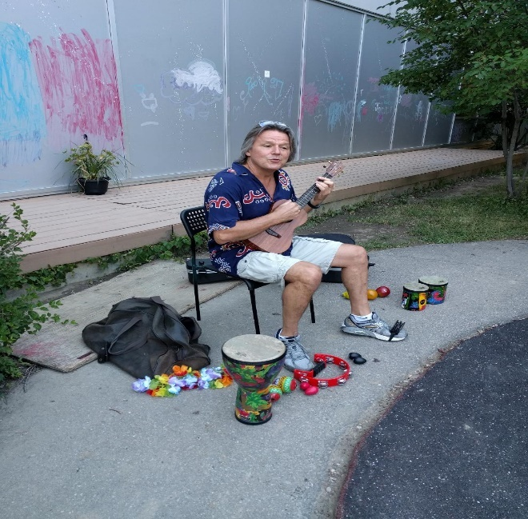

In celebration of Canada’s 151th Birthday, Jake Differ shared a diverse selection of music with the staff and children at YUCDC. His lyrics made everyone laugh and his rhythms made little feet dance. Jake’s unforgettable live performance has become a popular favourite at festivals and events across Canada. Jake is much acclaimed in the children’s music world. His debut CD, Take A Little Ride with Me, won a Parents’ Choice Gold Award and his Happy All of the Time CD earned a Juno Nomination for Children’s Album of the Year in 2006.

Jake’s concert was followed by a special barbeque luncheon which was prepared by both Folami Keyi and Sandra Bee. The luncheon was complete with their delicious red and white butter cream cupcakes!

YUCDC Welcomes our Summer Staffing Team!

Hilary Doan, a student who is completing her final year of Early Childhood Education at Ryerson University this fall, will be joining us this summer to further enrich our outdoor programs. She will be working closely with our staff and the student teachers from George Brown College to plan a fun-filled summer!

Lily Luu, who is currently pursuing Children’s Studies at York University, is a graduate from the School of Early Childhood Education at George Brown College. Lily will be working with us this summer to provide support while our staff vacation with their families.

Pervena Sivarajah is a student pursuing her final year of studies in Early Childhood Education at Humber College. Pervena, who brings many years of experience working in a variety of childcare settings, will be relieving our staffing teams to plan their programs in the mornings and will be our Preschool Support in the afternoons.

Sabrina Muglia is a recent graduate from York University’s Dance Studies Program and will be entering the Faculty of Education at York this Fall. Sabrina’s work with young children in dance, science and art for the City of Mississauga will be an asset to our Kinder and School Age Programs this summer.

YUCDC’s First Harvest Share!

Our Kitchen Team went to pick up their first Harvest Share last month. It included: egg plant, bok choy, mesclun mix, scallions, zebra zucchini, turnips and radishes.

Every week, for the next 23 weeks, we will be picking up organically grown produce grown at the Black Creek Community Farm. These vegetables are diverse and will be incorporated into our lunches throughout the week.
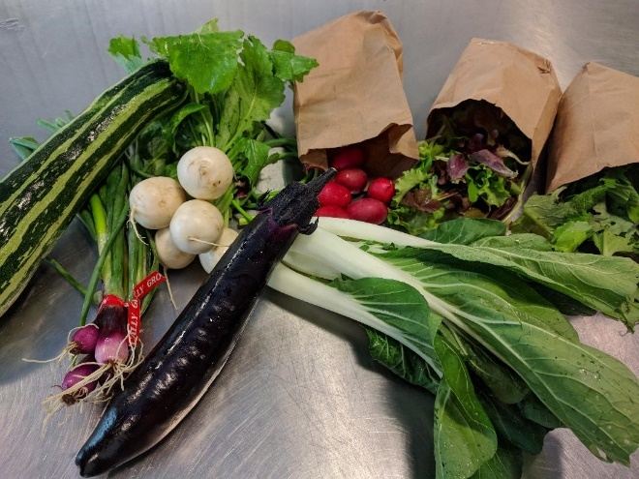

Tatiana Kekhman’s Musical Talents Come to YUCDC this Summer!

Tatiana Kekhman, who is a certified music teacher and is currently studying Early Childhood Education at Seneca College, brings her musical talents and experience into a variety of childcare settings. YUCDC has invited Tatiana into our Infant, Toddler and Preschooler Programs during the months of July and August.

YUCDC Welcomes Christopher Starr the Magical Jester!

Christopher Starr has been invited to YUCDC on Monday, July 16th to transport our children and staff to ‘Seuss Land’. This show comes with lots of audience participation, magic and a visit from a mascot character from The Cat in A Hat!

Christopher will return on Friday, August 10th with ‘Treasure Island Adventures’. In this Pirate Magic and Puppet Show, the children will set sail on the high seas looking for adventure and treasure. This show has been inspired by characters from Jake and the Neverland Pirates.

An Adventure to The African Lion Safari!

The Big Yellow School Bus will be taking our Kinders and School-Agers on a summer adventure. On Wednesday, August 1st, the children and staff in these programs will be going to the African Lion Safari. More details will follow!

YUCDC’s Partnership with York University’s Visual Studies Program

Our Preschoolers, Kinders and School Agers have been invited to engage in hands-on art projects in the Special Project Gallery at York University, during the week of August 13th. These projects will commence at the start of the week and end on the Saturday when everyone will be invited to an opening reception.

The Travelling Critters Visit YUCDC

Elise will be visiting our Infants, Toddlers, Preschoolers, Kinders and School-Agers with her Travelling Critters on the morning of Thursday, August 16th. Elise will be bringing learning opportunities that is so much fun that our children will not even realize that they are learning! Her programs are hands-on and cater to children of all ages.

An Invitation to Black Creek Community Farm

As a partner of Black Creek Community’s Healthy Challenge, an invitation to visit its farm was extended to some of our programs. On Tuesday, August 21st, our Preschoolers have been invited to participate in the morning ‘Little Farmers’ Program. This program is all about using one’s senses to touch, taste, see and hear all the amazing things at the farm. On Thursday, August 23rd, our Kinders and School-Agers will be participating in a Full Day Program where they will have the opportunity to be Farmers in Training, Outdoor Survivalists, Little Artists and Junior Chefs.

Our Teaching Gardens

Thank you for your donations of tires and perennials from your gardens! Our Teaching Gardens need many more tires. Our Staffing Team are using them as containers in which perennials are being planted. We are still in need of more perennials, especially those that attract butterflies. YUCDC is planning to introduce Educational Butterfly Raising Kits into its program next summer.

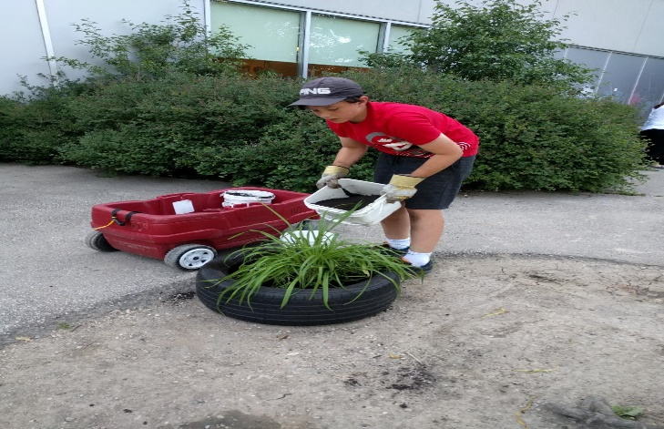
One of YUCDC’s alumni, Mike Boyer, recently came in to volunteer his services!

